**Termwork - 05**

**Steps in capturing packets in wireshark**

1. Open wireshark and double click on any interface to start the packet capture process
2. Open browser and enter any websites fully qualified domain name in the browser address bar and hit enter.
3. After site is fully loaded , stop the capturing process in wireshark
4. Type the following in, apply the filter column and hit enter

Tcp.flags.fin == 1 &&tcp.flags.ack == 1

1. Select any one of this and hover on the conversion filter and select tcp. Once done geeksforgeeks.com /wireshark tool

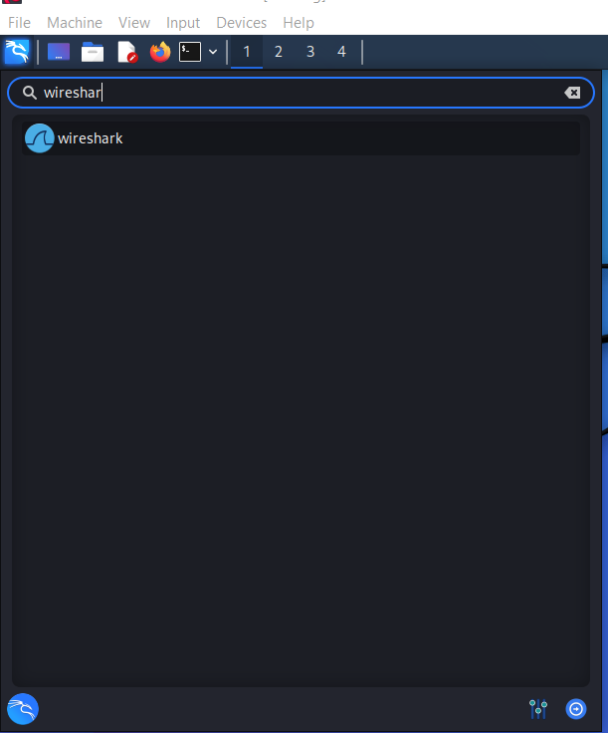

Search for wireshark in kali application

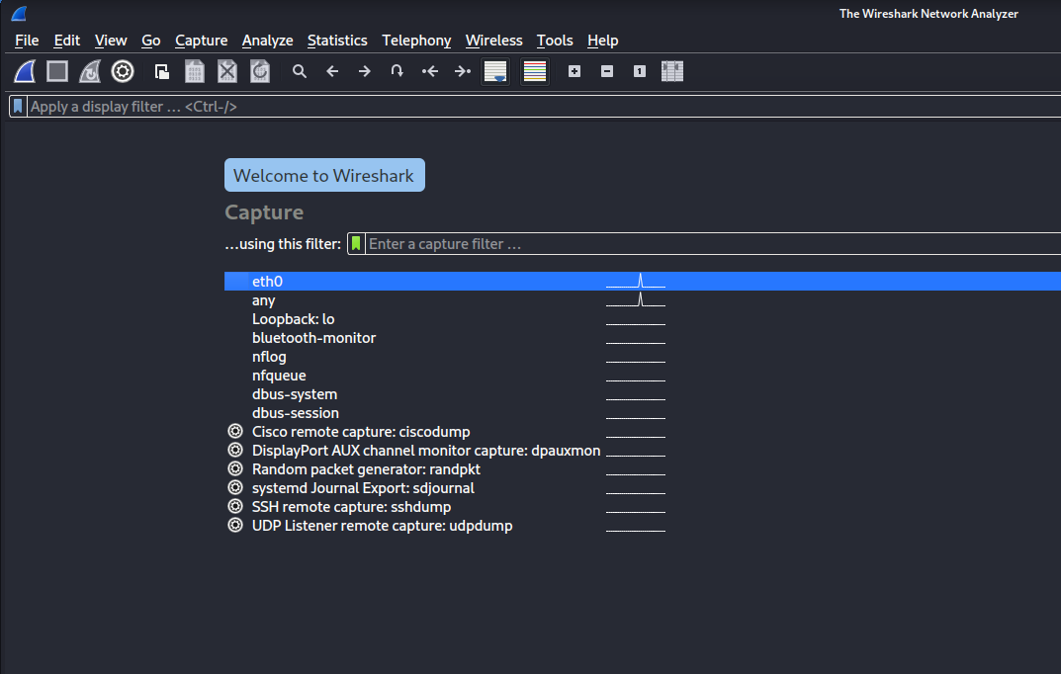

Click on Any

Open firefox and search any website

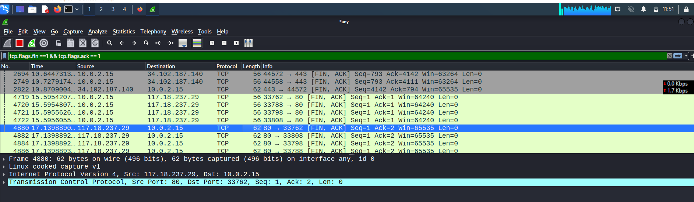

Wireshark starts capturing packets and we can apply filters (to know desired packets we required)